Create Repository :

In hub.docker.com

Use github to login

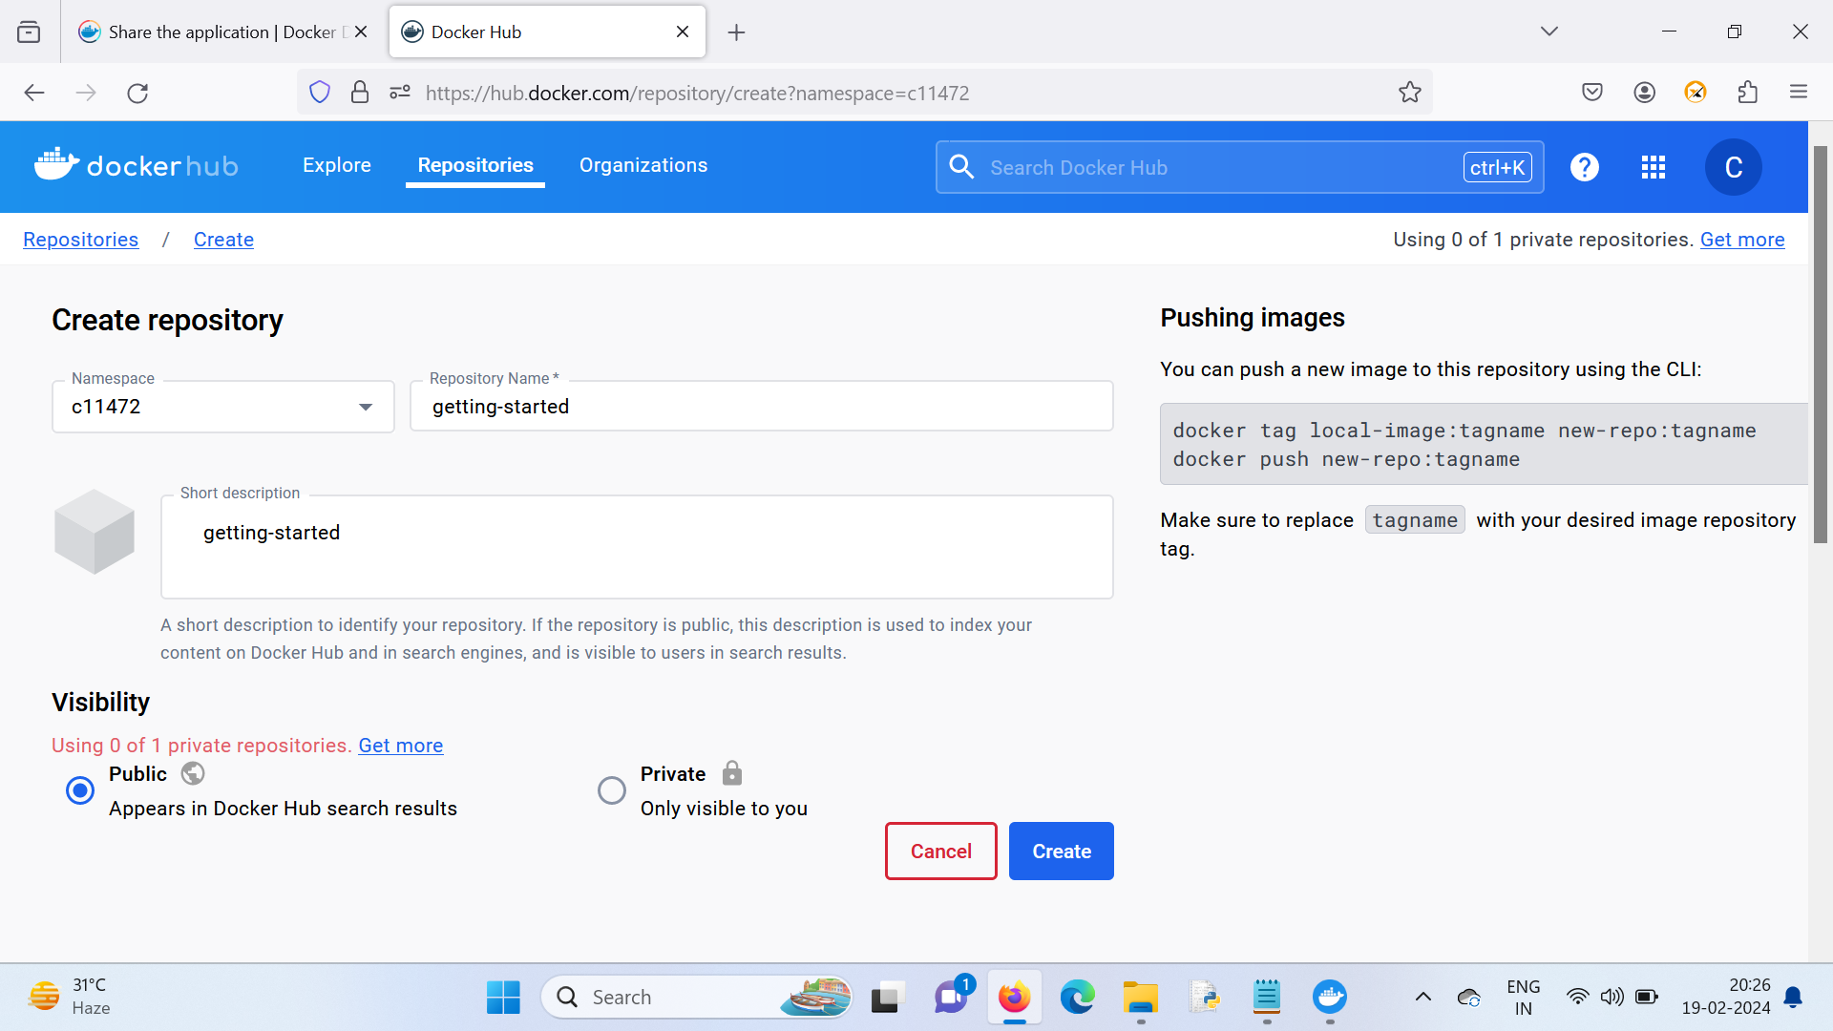

Click on create

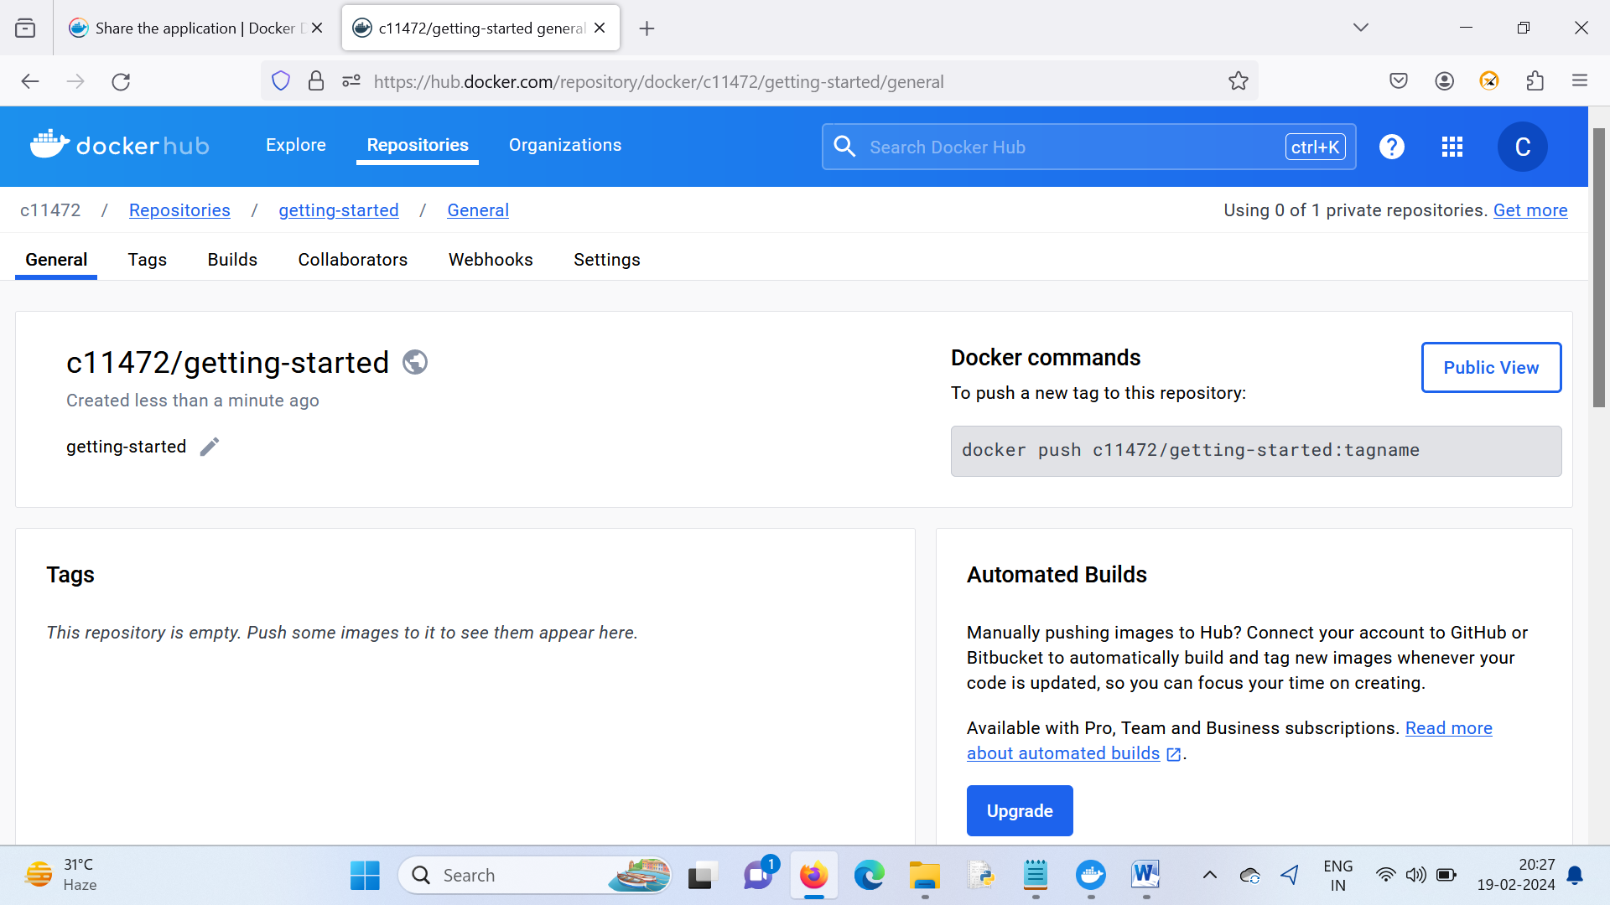

Command to push to dockerhub

docker push c11472/getting-started:tagname

docker pull redis

docker images

docker run redis

docker pull linuzilla/alpine-mariadb

docker run linuzilla/alpine-mariadb

docker ps

